SOUTHWESTERN ASSOCIATION

OF CRIMINAL JUSTICE

Arkansas - Arizona - Colorado - New Mexico - Oklahoma – Texas

Call for Presentations, Invitation to Participate, and Abstract Submission System

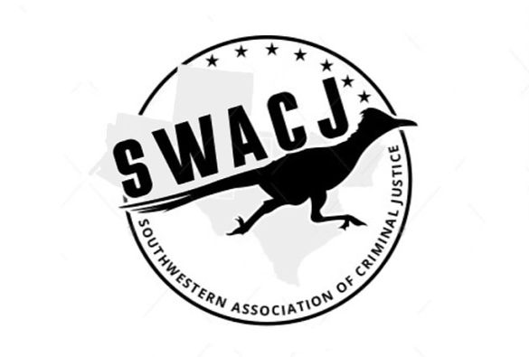

2024 ANNUAL MEETING

Conference Theme:

"Unprecedented Times: Criminology & Criminal Justice in an Uncertain World"

October 2-4, 2024

AC Hotel Fort Worth Downtown
Fort Worth, Texas

Abstracts will be accepted through the Southwestern Association of Criminal Justice website (https://www.swacj.org/conference) until September 1, 2024

